**Name: Session:**

**Programming II**

**Lab Exercise 4.28.2020**

In this application, you will need to use a Windows form. You may use my design or create your own.

1. The local Registry of Motor Vehicles office has asked you to create an application that grades the written portion of the driver’s license exam. The exam has 20 multiple choice questions. Here are the correct answers to the questions.

1. B 2. D 3. A 4. A 5. C 6. A 7. B 8. A 9. C 10. D

11. B 12. C 13. D 14. A 15. D 16. C 17. C 18. B 19. D 20. A

Your application should store the correct scores in an array. A form should allow the user to enter answers for each question.

When the user clicks the Score Exam button, the application should display whether each question was answered correctly or incorrectly and whether the student passed of failed the exam. A student must correctly answer 15 of the 20 questions to pass the exam. Only accept letters A, B, C, and D as answers. If you try to score your exam without answering all questions, the questions you answered will be scored and you will be given the opportunity to answer questions until you have provide 20 valid answers.

The application should have a reset and quit button.

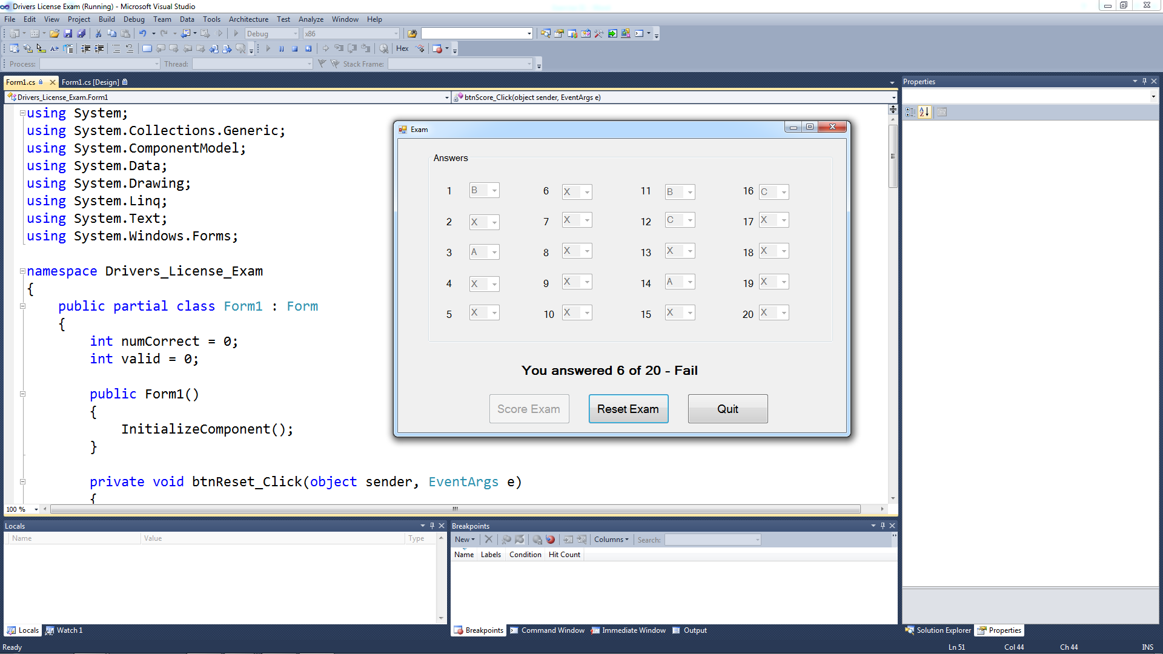

1. Add the following code to the btnReset_Click event handler.

ComboBox[] scores = new ComboBox[] {ComboBox1, ComboBox2, ComboBox3,

ComboBox4, ComboBox5, ComboBox6, ComboBox7, ComboBox8, ComboBox9,

ComboBox10, ComboBox11, ComboBox12, ComboBox13, ComboBox14, ComboBox15, ComboBox16, ComboBox17, ComboBox18, ComboBox19, ComboBox20};

for (int index = 0; index <= 19; index++)

{

scores[index].Enabled = true;

scores[index].Text = "";

scores[index].ForeColor = Color.Black;

}

btnScore.Enabled = true;

lblResult.Text = "";

numCorrect = 0;

valid = 0;

1. Add the following code to the btnScore_Click event handler.

ComboBox[] scores = new ComboBox[] {ComboBox1, ComboBox2, ComboBox3,

ComboBox4, ComboBox5, ComboBox6, ComboBox7, ComboBox8, ComboBox9,

ComboBox10, ComboBox11, ComboBox12, ComboBox13, ComboBox14, ComboBox15, ComboBox16, ComboBox17, ComboBox18, ComboBox19, ComboBox20};

string[] correct = new string[] {"B", "D", "A", "A", "C", "A", "B", "A",

"C", "D", "B", "C", "D", "A", "D", "C", "C", "B", "D", "A"};

for (int index = 0; index <= 19; index++)

{

//check if answer is valid

if (scores[index].Text != "")

{

valid++;

}

else

continue;

//Check if valid answer is correct

if (scores[index].Text == correct[index])

{

numCorrect++;

scores[index].Text = scores[index].Text;

scores[index].Enabled = false;

}

//check if answer is wrong

else

{

scores[index].ForeColor = Color.Red;

scores[index].Text = "X";

scores[index].Enabled = false;

}

} //end of for loop

//check for all questions answered

if (valid == 20)

{

//check for pass

if (numCorrect >= 15)

lblResult.Text = "You answered " + numCorrect.ToString() + " of 20 - Pass";

//check for fail

else

lblResult.Text = "You answered " + numCorrect + " of 20 - Fail";

btnScore.Enabled = false;

}

else

{

lblResult.Text = "You have not answered all of the questions";

valid = 0;

numCorrect = 0;

}

1. Test your program

**When you have completed your application, print a screenshot of your running application and turn in.**